**GraphQL Subscription**

**For Real time update in user website**

Before Subscription we perform query and mutation. Query is used for what data we want to get and Mutation what we want to perform Create, Update and Deleted etc. Let's come to part of the subscription. When Subscription concepts weren't released for the updation of data engineers used the concept of polling. Polling means it sends the request in particular milliseconds but it increases the overheads. Subscription resolved this issue. Subscription has an important role when a user wants to subscribe, update data at the same time.

**Why we use Subscription and benefits:-**

1. Small and incremental changes to large Objects.
2. Real time updates, low latency, less expensive and time consuming compared to polling.

**This is the flow of Subscription:-**

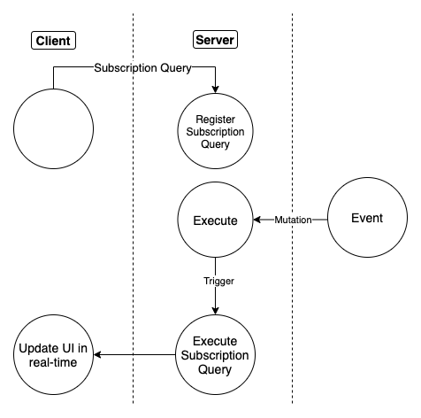

**We follow the following steps:-**

1. Install library

npm install @apollo/client subscriptions-transport-ws

1. Initialize a WebSocket link

import { WebSocketLink } from '@apollo/client/link/ws';

const wsLink = new WebSocketLink({ uri: 'ws://localhost:5000/graphql', options: { reconnect: true } });

1. Split communication by operation

import { split, HttpLink } from '@apollo/client';

import { getMainDefinition } from '@apollo/client/utilities'; import { WebSocketLink } from '@apollo/client/link/ws';

const httpLink = new HttpLink({

uri:'http://localhost:3000/graphql'

});

const wsLink = new WebSocketLink({ uri:'ws://localhost:5000/graphql',

options: { reconnect: true }

});

const splitLink = split(

({ query }) => {

const definition = getMainDefinition(query);

return (

definition.kind === 'OperationDefinition' && Authenticate over WebSocket

import { WebSocketLink } from '@apollo/client/link/ws';

const wsLink = new WebSocketLink({

uri: 'ws://localhost:5000/graphql',

options: {

reconnect: true,

connectionParams: {

authToken: user.authToken,

},

},

});

definition.operation === 'subscription'

);

},

wsLink,

httpLink,

);

1. Execute a Subscription

That’s all about Subscription.